UI/UX
OSCAR PEREIRA – DAW 7K

Choose a website you use often and try to apply, or relate this concepts to the website.

-real world knowledge
-learned behaviour whe we approachd design
-cause and effect: action and reaction- when we interact with one element and the expectations we have about it
-consistency: equals elements should work the same way
-seamless interactions
-intuition about how elements work
-payoff results
-undo/redo

For this activity the website chosen to be analysed will be Youtube, one that most people is familiar with, not only for its longevity in the market and its presence on everyones life, but because it makes use of many elements that people find familiar from having seen them in the real world.

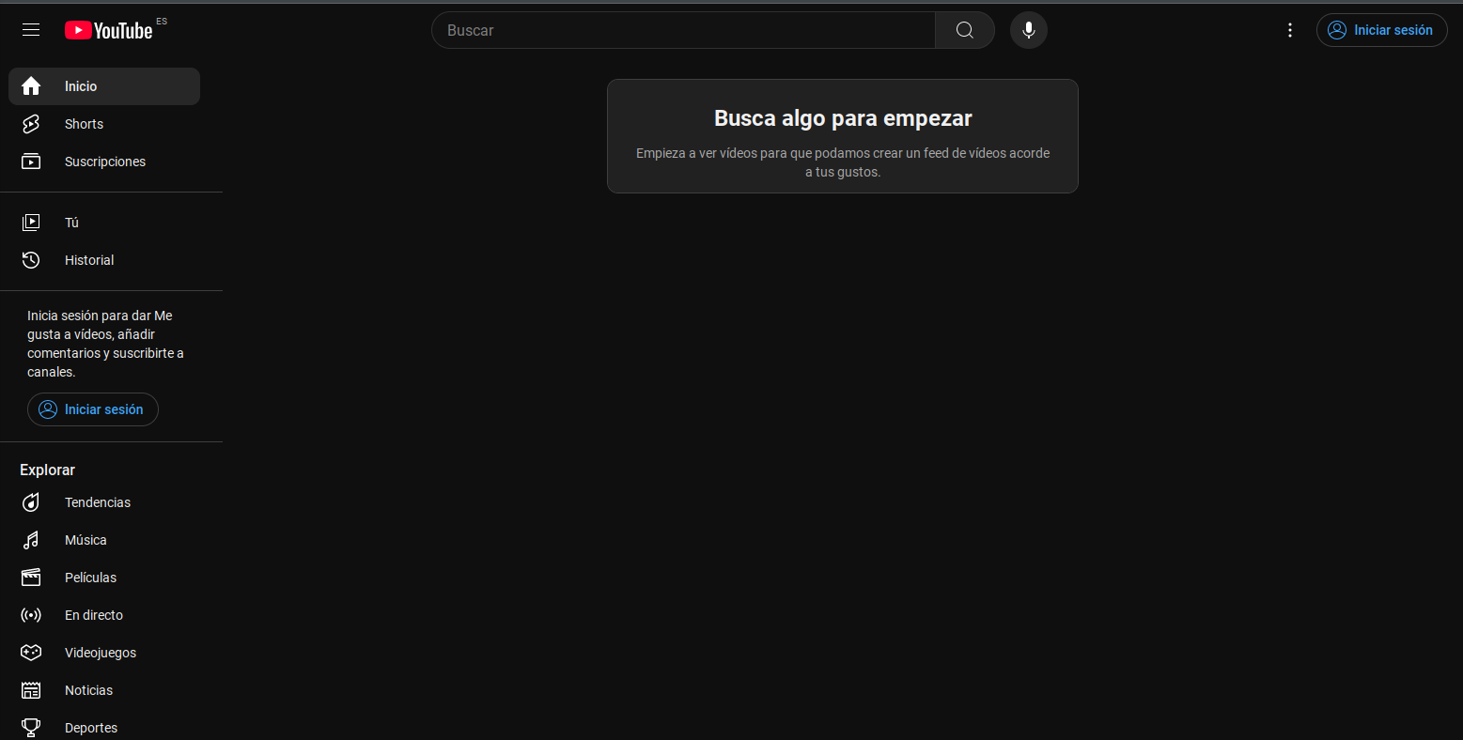

Upon entering the website, its landing page greets us with a simple message, encouraging the user to use the Search Bar to look for content they might like.



The search bar has been a standard in all applications, it allows to look for relevant content by introducing keywords.

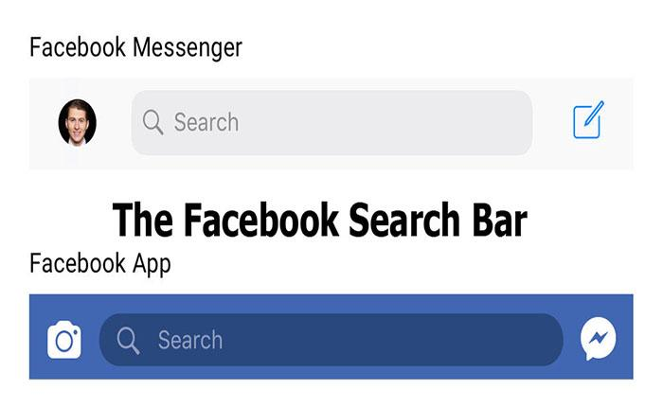

In the lateral navigation bar we can find many buttons, each with simple and intuitive names, hinting at its function.

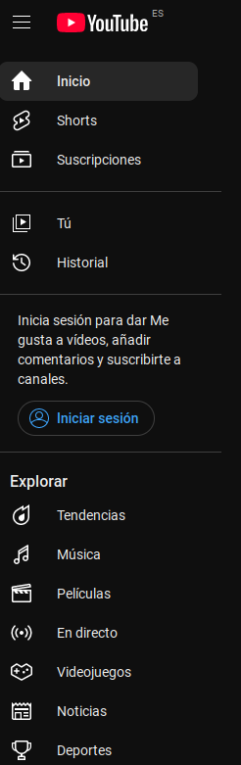

It shows many categories, mainly those that are of interest for most people accesing the website.

The icons displayed at the side of each button also helps portray the meaning and use of the button its assosiciated with, allowing for a broader variety of users, specially those that might not be able to read, a music note for the music section, a trophy for the sports one, a newspaper for the news and so on…

Notice how many of the icons presented in the website are the same as those of a TV remote controller:

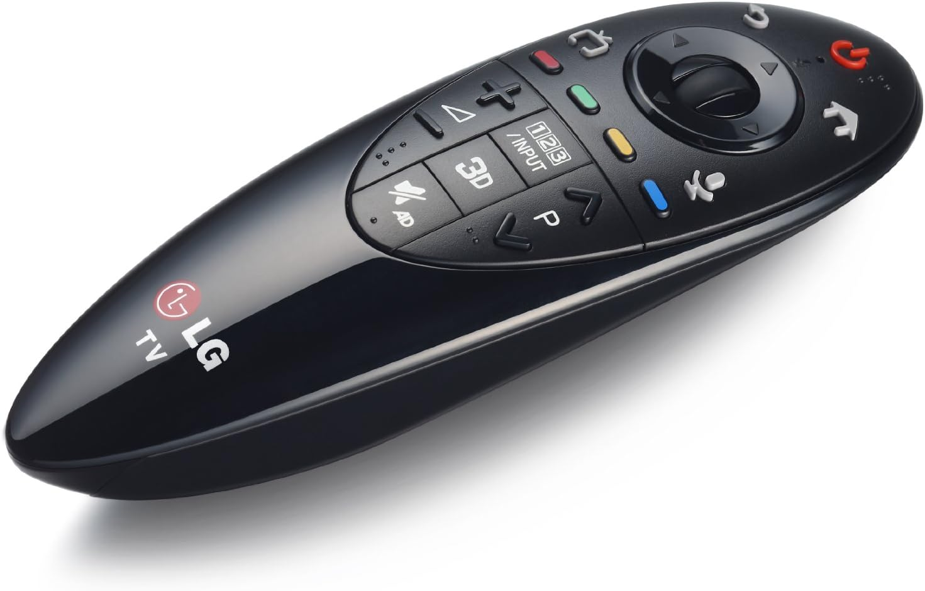

Not everyone can speak chinese, however by looking at this image you can have a vague idea of where each button will lead you to:

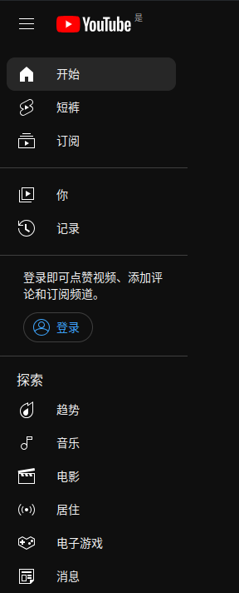

---------------------------------------

To demonstrate the ease of use of this website, just by writing a few words in the search bar you are presented with many suggestion that might fit what the user is looking for.

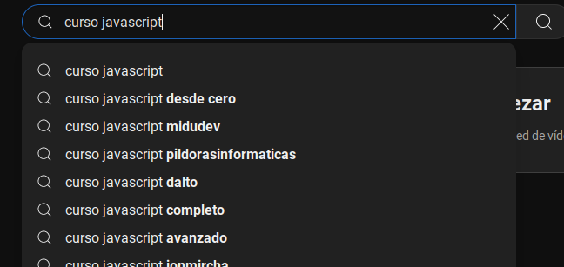

And with just a single click, any of those will lead us to relevant content.

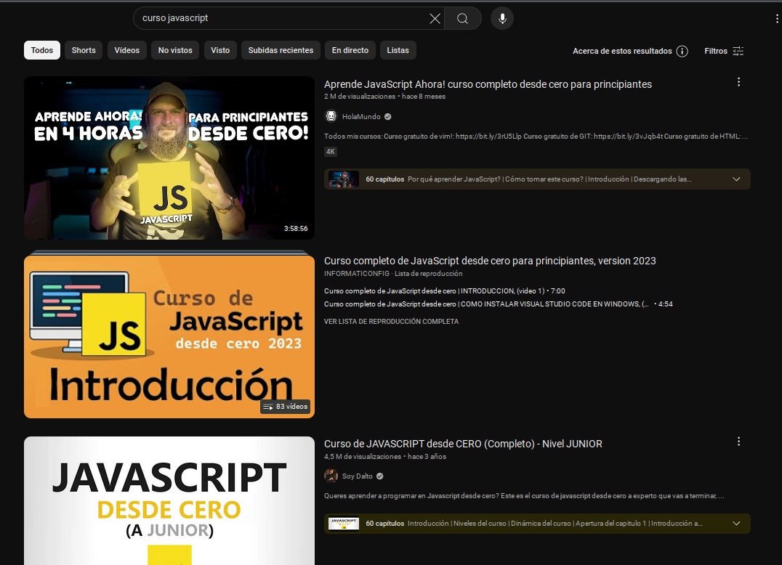

The way the content is presented is descriptive in a way that is both visual and textual, this has been the preferred way to showcase multimedia content in many audio/videos platforms for a while now, as for the older people or those that are not technically inclined it helps that it resembles the old TV/Product catalogues.

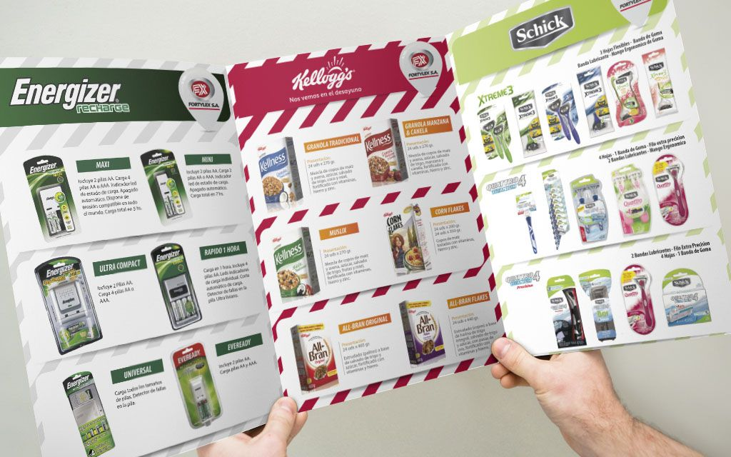

You can get an inmediate feedback and access the video with just a single click, which leads to a straightforward presentation.

The video which occupies most of the screen, a few recommendations that might be related to the video itself, a small description left by the video creator and a simple thumbs up/down button, which in real world are used to indicate if something is liken or not.

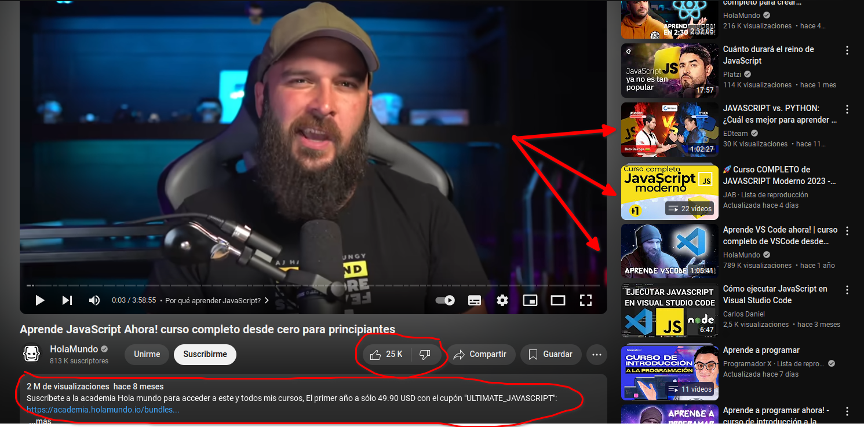



In conclusion, we can see how Youtube makes use of many elements present in our everyday life, either from items from the physical world or by making use of conventions presented in other products, all of this to create an interface that provides an accesible and intuitive experience, which has greatly contributed to its success.

